Automobile Accident form

Patient name: _____________________________________ Date: _______/_______/________

Social Security # ________/________/__________ Date of Birth: _____/______/ ______

Date of injury: ________/_________/___________ Time of injury: _____________OAM OPM

Location of accident: ________________________________________________________________

Were you the O Driver O Passenger O Pedestrian? Estimated damage to vehicle: ________________

Do you have automobile personal injury insurance coverage? O Yes O No

Insurance company: ____________________________ Policy # _______________________________

Adjustor Name: ________________________________ Phone: ________________________________

Claim #: ______________________________________ Coverage Limit: $________________________

O YES O NO Have you reported this injury to your car insurance company?

O YES O NO Did the police come to the scene and make a report?

O YES O NO Was anyone issued a citation?

O YES O NO Were you seen by a paramedic? O YES O NO Went to emergency room?

O YES O NO Do you have an attorney for this case? Name/address/phone:

____________________________________________________________________________________
____________________________________________________________________________________
Where was your car hit? O Front O BACK O Driver’s side O Passenger’s side
O YES O NO Was you car moving? MPH _____ O YES O NO Was the other car moving? MPH ____

Please describe the accident: ____________________________________________________________________

____________________________________________________________________________________
____________________________________________________________________________________
At the time of impact your vehicle was:
O Stopped O Slowing down O Gaining Speed O Moving steady
At the time of impact, the other vehicle was:
O Stopped O Slowing down O Gaining Speed O Moving steady

During and after the crash, your vehicle:
O Kept going straight, not hitting anything O Spun around, not hitting anything
O Kept going straight, hitting the car in front O Spun around, hitting another car
O Was hit by another vehicle O Spun around, hitting object or other car
Describe yourself during the crash: (check only areas that apply to you)
O You were unaware of the impending collision O You were aware, and relaxed before the collision
O You were aware of the impending collisions and braced yourself
O Your body, torso, and head were facing straight ahead.
O You had your head and/or torso turned at the time of collision: O Left O Right
O You were intoxicated (Alcohol/other substance) at the time of crash
O You were wearing a seatbelt. If yes, does it have a shoulder harness? O YES O NO
O You were holding on to the steering wheel at the time of impact.
Indicate if your body hit something or was hit by any of the following:
Please draw lines and match the left column to the right column.
Head Windshield O YES O NO Did you lose consciousness?

Face Steering Wheel
Shoulder Side Door
Neck Dashboard
Chest Car Frame
Hip Another Occupant
Knee Seat
Foot Seat Belt
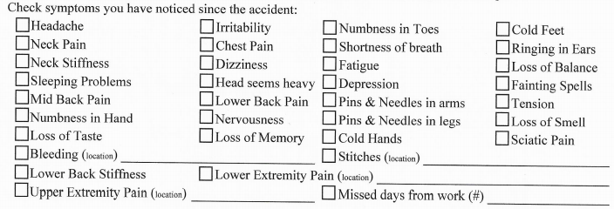
How did you feel after the accident? ______________________________________________________

Check if any of the following vehicle parts broke, bent, or were damaged in your car:

O Windshield O Seat frame O Knee bolster O Steering Wheel O Side/rear window

O Dashboard O Mirror O Other: _______________________________________________

Rear-end collisions only: (Answer this section if you were hit from the rear)
Does your vehicle have:
O Moveable head restraints O Fixed, non-moveable head restraints O No head restraints
Please indicate how your head restraint was positioned at the time of the crash:
O At the top of the back of your head O Midway height of the back of your head
O Lower height of the back of your head O At the back of your neck
O At the level of your shoulder blades (Upper back) below your neck

All types of collisions:

O YES O NO Did any of the front of your side structures, such as side door, dashboard, or floor board of your car, dent inward during the crash?

O YES O NO Did the side door touch your body during the crash?
O YES O NO Were your hands on the steering wheel or dashboard during the crash?
O YES O NO Did your body slide under the seat belt?
O YES O NO Was a door of your vehicle damaged to the point where you could not open the door?

Emergency Department

O YES O NO Did you go to the emergency department after the accident?
What is the name of the hospital? ____________________ (time/date) ____________________
O YES O NO Did another person drive you to the hospital? O YES O NO Overnight stay?
O YES O NO Did the emergency Dr. take any X-Rays?
O Skull O Neck O Mid back O Low Back O arm/leg O Other_____________________________
O YES O NO Did the emergency Doctor prescribe you any pain medication?
O YES O NO Did the emergency Doctor prescribe you any muscle relaxants?
O YES O NO Did you have any cuts/lacerations? O YES O NO Did they require stitches?
O YES O NO Were you given a collar or neck brace to wear?

When did you first notice any pain after the injury?
O Immediately O ______ hours after injury O ______ Days after injury

If you did not see a doctor for the first week after the injury, indicate why: (Check all the apply)
O No pain was noticed O No appointments available
O No transportation O Work/school schedule did not permit

If you did not see a doctor for the first month after the injury, indicate why: (Check all the apply)
O No pain was noticed O No appointments available
O No transportation O Work/school schedule did not permit
O I thought pain would go away O I had no insurance or money
O I self-treated with over-the-counter drugs O Took hot showers, used ice and heat
Have you been unable to work since injury? O YES ( ___ Partially ___ Completely) O NO
Please list date(s) off work: ___/___/____ to ___/___/____

ASSIGNMENT OF BENEFITS / ERISA AUTHORIZED REPRESENTATIVE FORM

Financial Responsibility
I have requested professional services from Back In Line Chiropractic Center (“Provider”) on behalf of myself and/or my dependents, and understand that by making this request, I am responsible for all charges incurred during the course of said services. I understand that all fees for said services are due and payable on the date services are rendered and agree to pay all such charges incurred in full immediately upon presentation of the appropriate statement unless other arrangements have been made in advance.

Assignment of Insurance Benefits
I hereby assign all applicable insurance benefits to which I and/or my dependents are entitled to Provider. I certify that the insurance information that I provided to Provider is accurate as of the date set forth below and that I am responsible for keeping it updated.

I hereby authorize Provider to submit claims, on my, and/or my dependent’s behalf, to the benefit plan (or its administrator) listed on the current insurance card I provided to Provider, in good faith. I also hereby instruct my benefit plan (or its administrator) to pay Provider directly for services rendered to me or my dependents. To the extent that my current policy prohibits direct payment to Provider, I hereby instruct and direct my benefit plan (or its administrator) to provide documentation stating such non-assignment to myself and Provider upon request. Upon proof of such non-assignment, I instruct my benefit plan (or its administrator) to make out the check to me and mail it directly to Provider.

I am fully aware that having insurance does not absolve me of my responsibility to ensure that my bills for professional services from Provider are paid in full. I also understand that I am responsible for all amounts not covered by my insurance, including co-payments, co-insurance, and deductibles.

Authorization to Release Information
I hereby authorize Provider to: (1) release any information necessary to my insurance benefit plan (or its administrator) regarding my illness and treatments; (2) process insurance claims generated in the course of examination or treatment; and (3) allow a photocopy of my signature to be used to process insurance claims. This order will remain in effect until revoked by me in writing.

ERISA Authorization
I hereby designate, authorize, and convey to Provider to the full extent permissible under law and under any applicable insurance policy and/or employee health care benefit plan, as my Authorized Representative: (1) the right and ability to act on my behalf in connection with any claim, right, or cause in action that I may have under such insurance policy and/or benefit plan; and (2) the right and ability to act on my behalf to pursue such claim, right, or cause of action in connection with said insurance policy and/or benefit plan (including but not limited to, the right to act on my behalf in respect to a benefit plan governed by the provisions of ERISA as provided in 29 C.F.R. §2560.5031(b)(4)) with respect to any healthcare expense incurred as a result of the services I received from Provider and, to the extent permissible under the law, to claim on my behalf, such benefits, claims, or reimbursement, and any other applicable remedy, including fines.

A photocopy of this Assignment/Authorization shall be as effective and valid as the original.

Patient Date

Policyholder/Insured Date

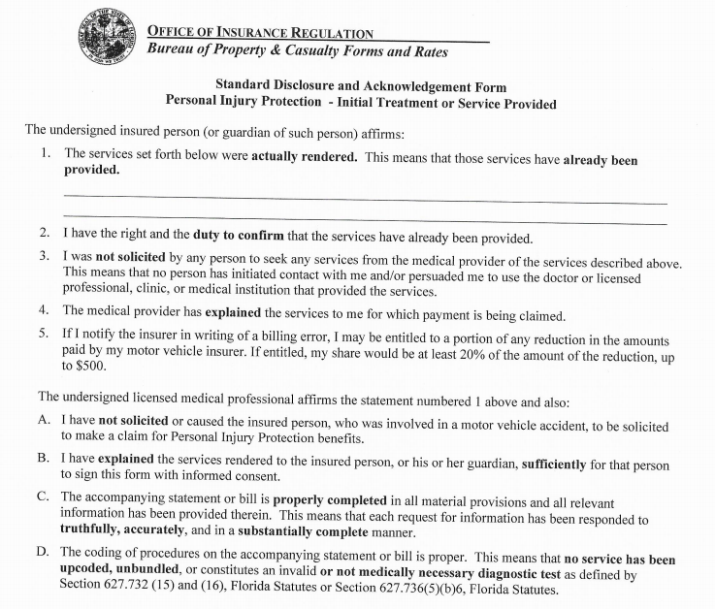
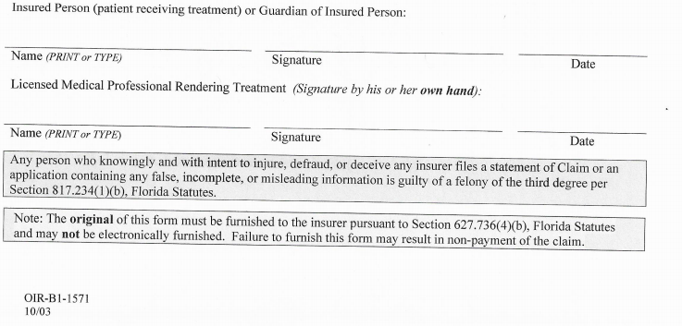
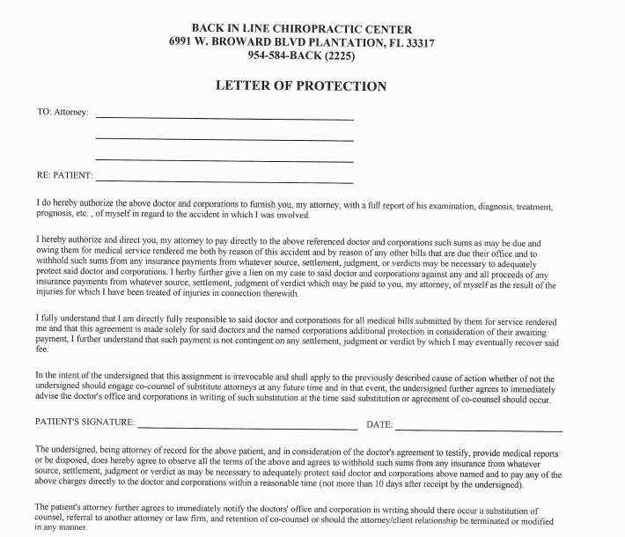

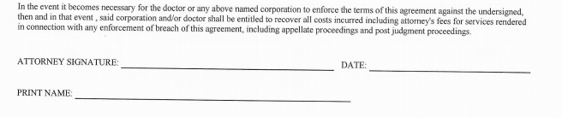

PATIENT DISCLOSURE AND
ACKNOWLEDGEMENT FORM

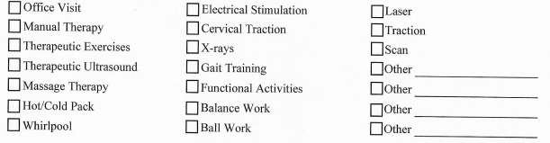
- I acknowledge that I received the treatment(s) listed above.
- I acknowledge that I have the right and affirmative duty to confirm that services listed were rendered.
- I was not solicited by this medical facility or any of it’s employees to seek medical treatment for injuries sustained as a result of this accident.
- I understand that if the insured notifies the insurer in writing of any billing errors, the insured may be entitled to a certain percentage of the reduction in the amounts being paid by the insured’s motor vehicle insurer.
- The services being provided to me for which my Doctor intends to bill my insurance have been explained. I have had the opportunity to have any questions answered to my satisfaction.
- I hereby acknowledge having been informed of the above and have consented to the treatment and billing for the treatment proposed by my provider.

__________________________________ ______________________
Patient’s signature Date

__________________________________
Patient’s name

__________________________________ _______________________
Provider’s Signature Date

